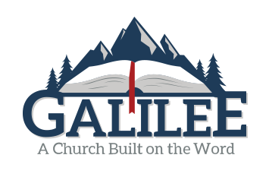

The

Think Again
1 Corinthians 15:29-34
December 13th, 2020

3 Reflections:

1. Wrong thinking leads to weird worship (v. 29).
2. Right thinking motivates a fearless faith (vv. 30-32a).
3. Wrong thinkers end up in a sinful stupor (vv. 32b-34).

Wrong thinking corrupts our Christianity
while causing us to fail in our gospel testimony.

